CREATE DATABASE FIRST_ASSIGEMENT_SHAILESH_1

CREATE TABLE SALES_PERSON

(

SNO INT PRIMARY KEY,

SNAME VARCHAR(50) NOT NULL,

CITY VARCHAR(50),

COMM FLOAT);

INSERT INTO sales_person VALUES

(1001,"PEEL","LONDON",0.12),

(1002,"SERRES","SAN JOSE",0.13),

(1003,"AXELROD","NEW YORK",0.1),

(1004,"RAFKIN","BARCELONA",0.11),

(1007,"MOTIKA","LONDON",0.15);

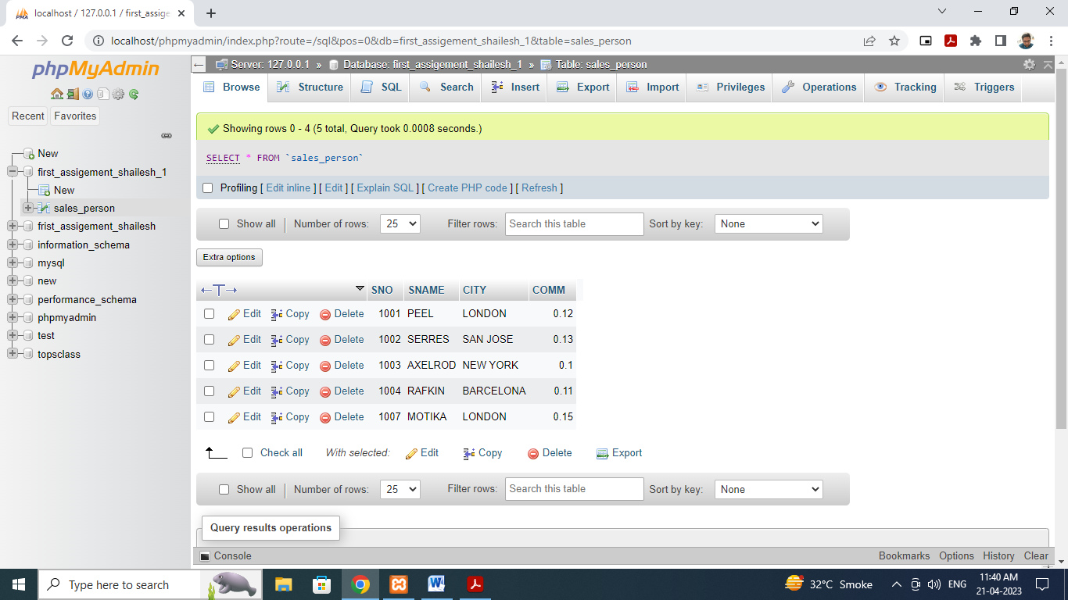

CREATE TABLE CUSTOMER

(

CNM INT PRIMARY KEY,

CNAME VARCHAR(50),

CITY VARCHAR(50),

RATING INT,

SNO INT)

INSERT INTO customer VALUES

(201,"HOFFMAN","LONDON",100,1001),

(202,"GIOVANNE","ROME",200,1003),

(203,"LIU","SAN JOSE",300,1002),

(204,"GRASS","BARCELONA",100,1002),

(206,"CLEMENS","LONDON",300,1007),

(207,"PEREIRA","ROME",100,1004);

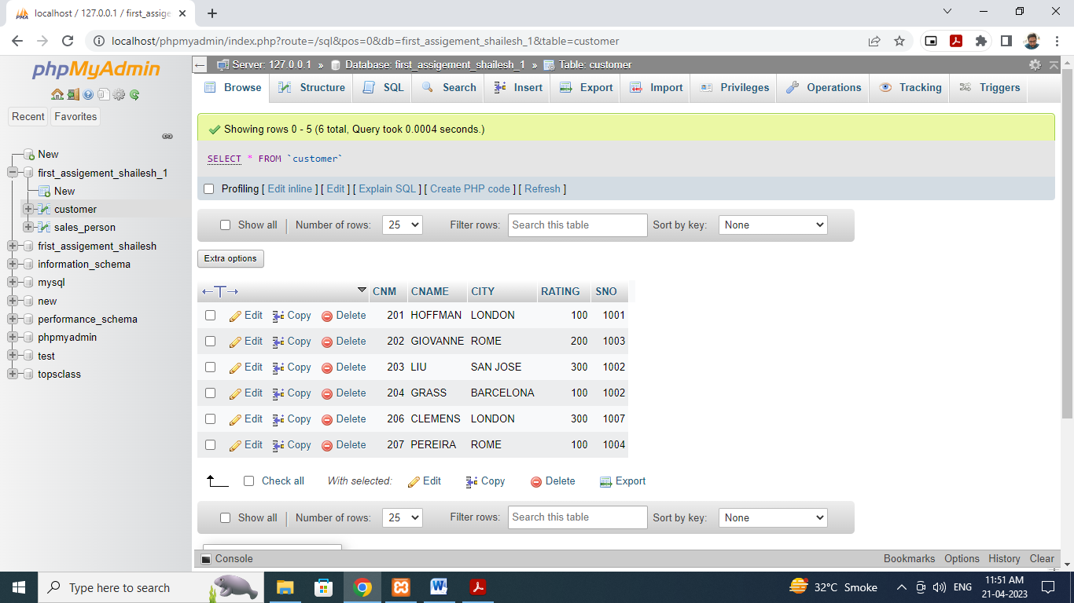

CREATE TABLE ORDERS(ONM INT,AMT FLOAT,ODE DATE,CNM INT,SNO INT);

INSERT INTO orders(ONM,AMT,ODE,CNM,SNO)VALUES

(3001,18.69,"1994-10-03",201,1007),

(3002,1900.1,"1994-10-03",207,1004),

(3003,767.19,"1994-10-03",201,1001),

(3005,767.19,"1994-10-03",203,1002),

(3006,3005,"1994-10-04",201,1007),

(3007,3007,"1994-10-05",204,1002),

(3008,3008,"1994-10-05",206,1001),

(3009,3009,"1994-10-04",202,1003),

(3010,3010,"1994-10-06",204,1002),

(3011,3011,"1994-10-06",206,1001);

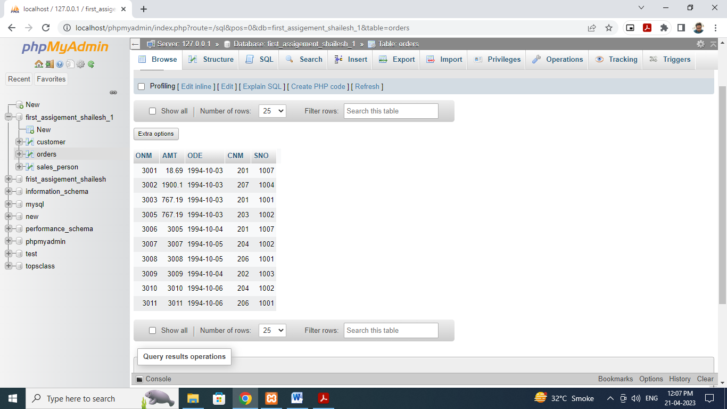

1. All orders for more than $1000.

SELECT*FROM orders WHERE AMT>1000;

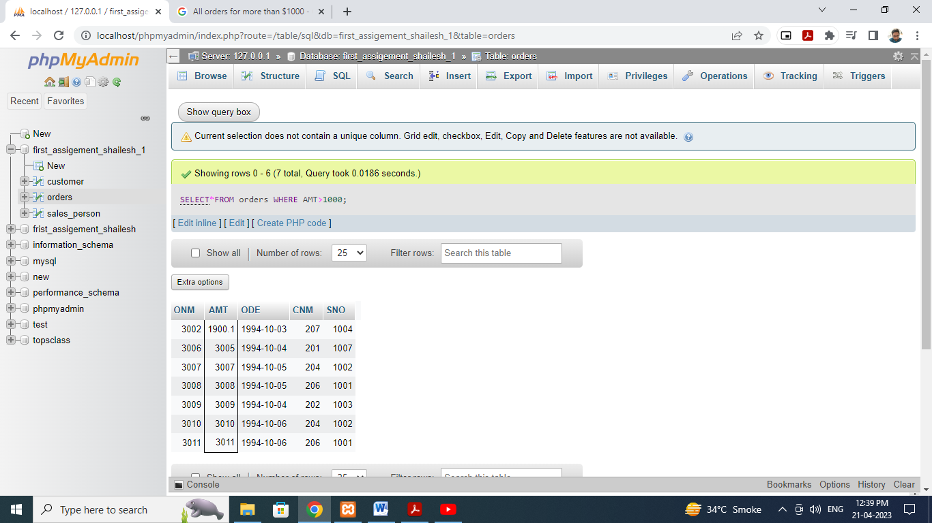

2)Names and cities of all salespeople in London with commission above 0.10

SELECT sales_person.SNAME,sales_person.CITY,sales_person.COMM FROM sales_person

WHERE CITY="LONDON" AND COMM>0.10;

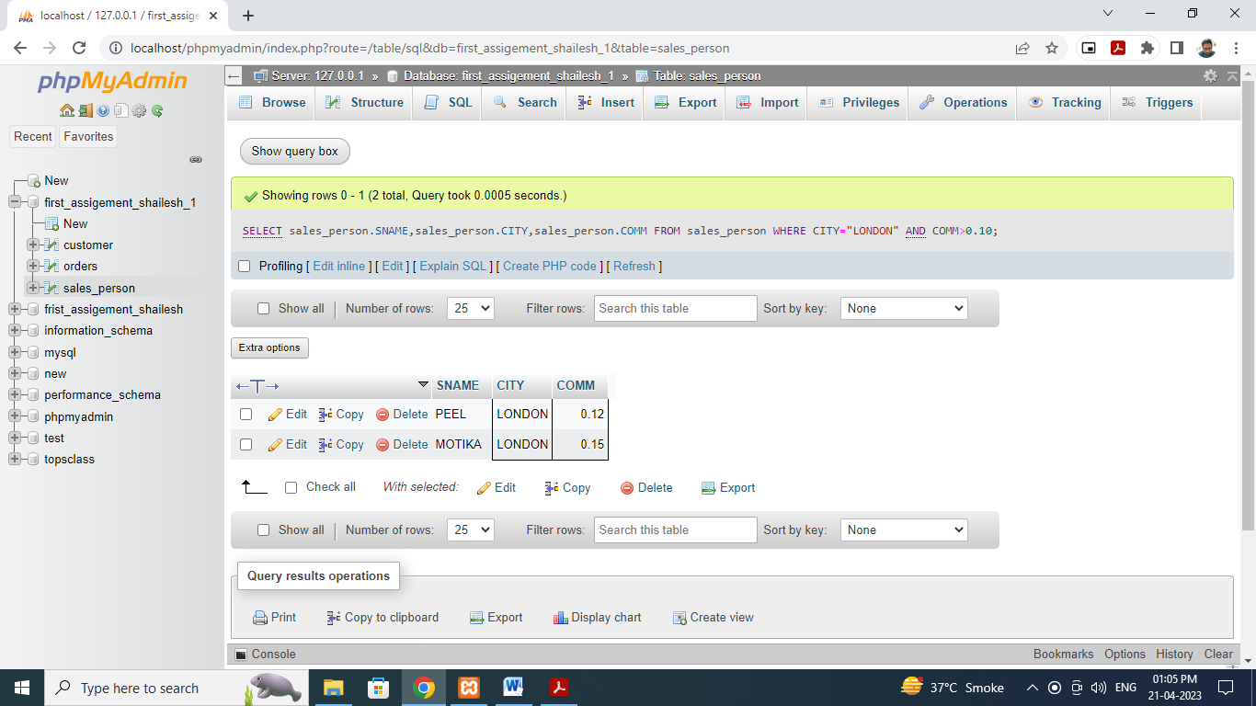

3)All salespeople either in Barcelona or in London.

SELECT*FROM sales_person WHERE CITY="BARCELONA"OR CITY="LONDON";

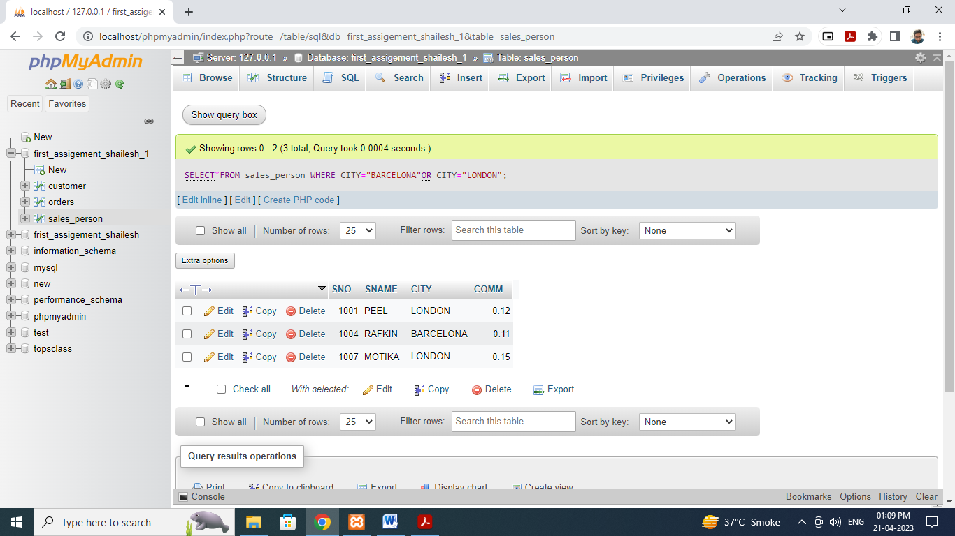

4) All salespeople with commission between 0.10 and 0.12. (Boundary values should

be excluded).

SELECT*FROM sales_person

WHERE COMM>0.10 AND COMM<0.12;

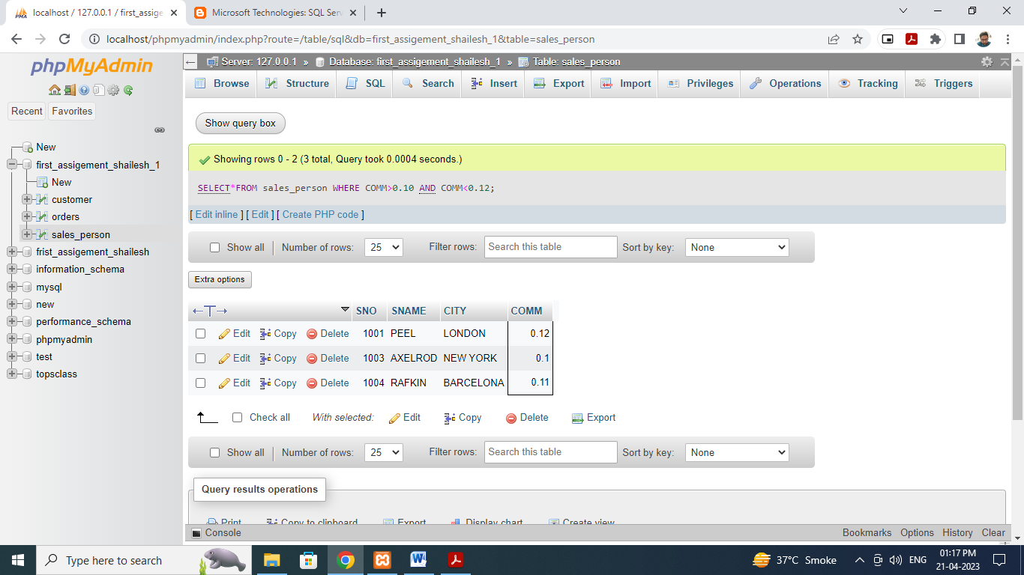

5) All customers with NULL values in city column.

UPDATE customer SET CITY="" WHERE CNM=203;

SELECT*FROM customer WHERE CITY IS NULL;

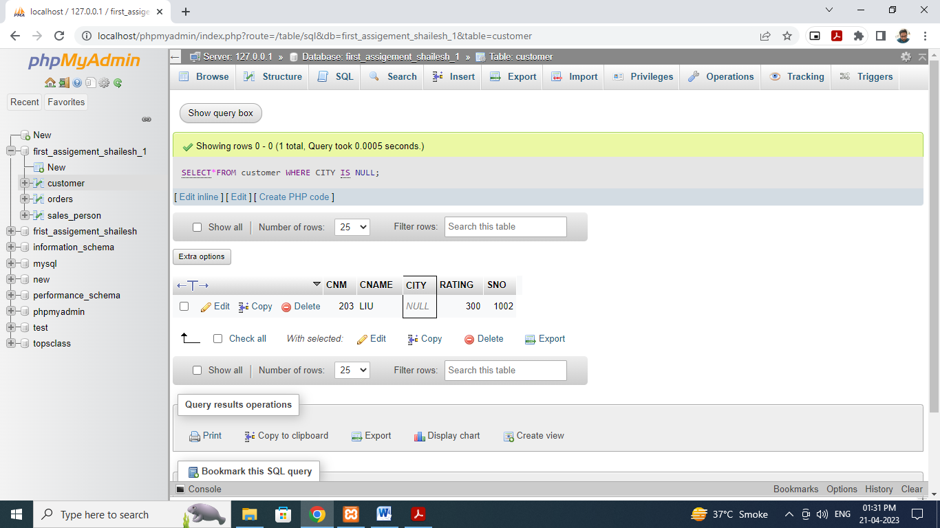

6) All orders taken on Oct 3Rd and Oct 4th 1994.

SELECT*FROM orders WHERE ODE IN("1994-10-03","1994-10-04")

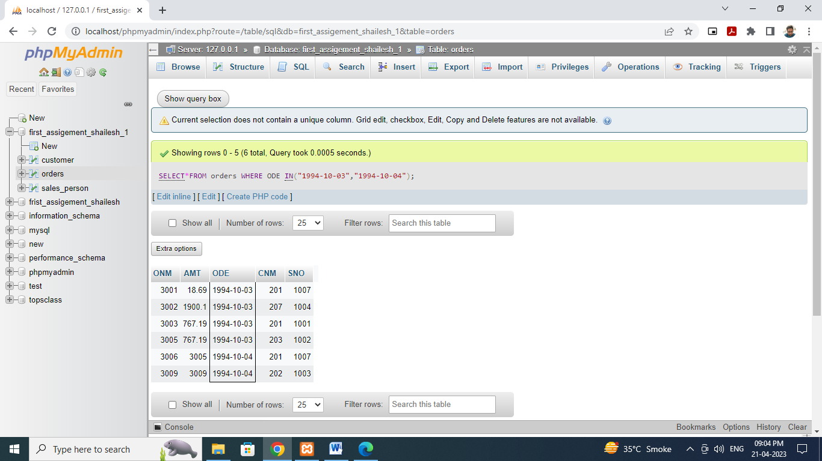

7) All customers serviced by peel or Motika.

SELECT *FROM customer

WHERE SNO IN(SELECT SNO FROM sales_person WHERE sname="peel" or SNAME="Motika")

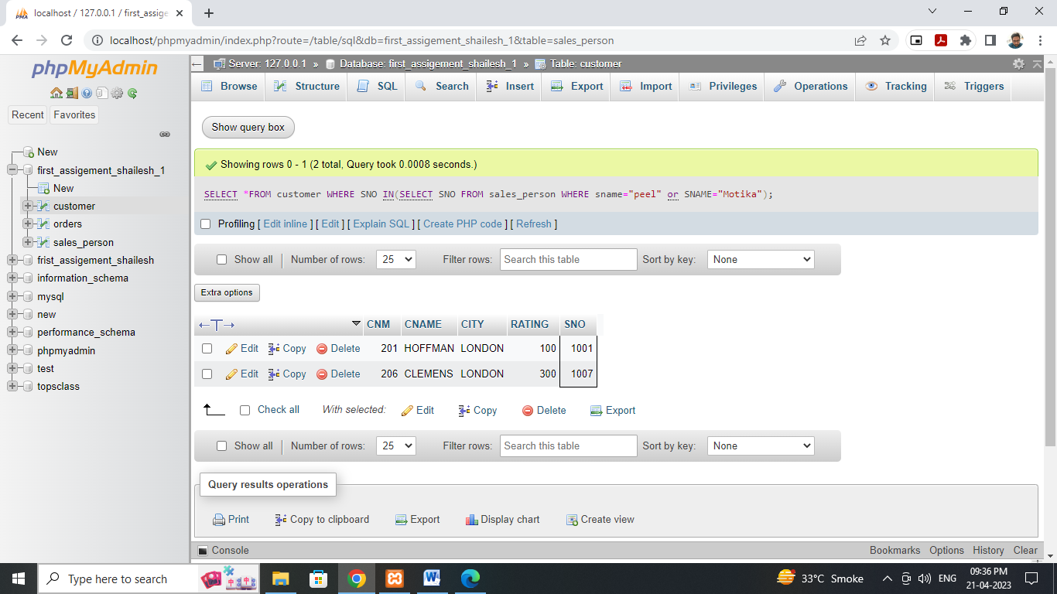

8) All customers whose names begin with a letter from G to C

SELECT*FROM customer WHERE CNAME like "G%" or CNAME LIKE"C%";

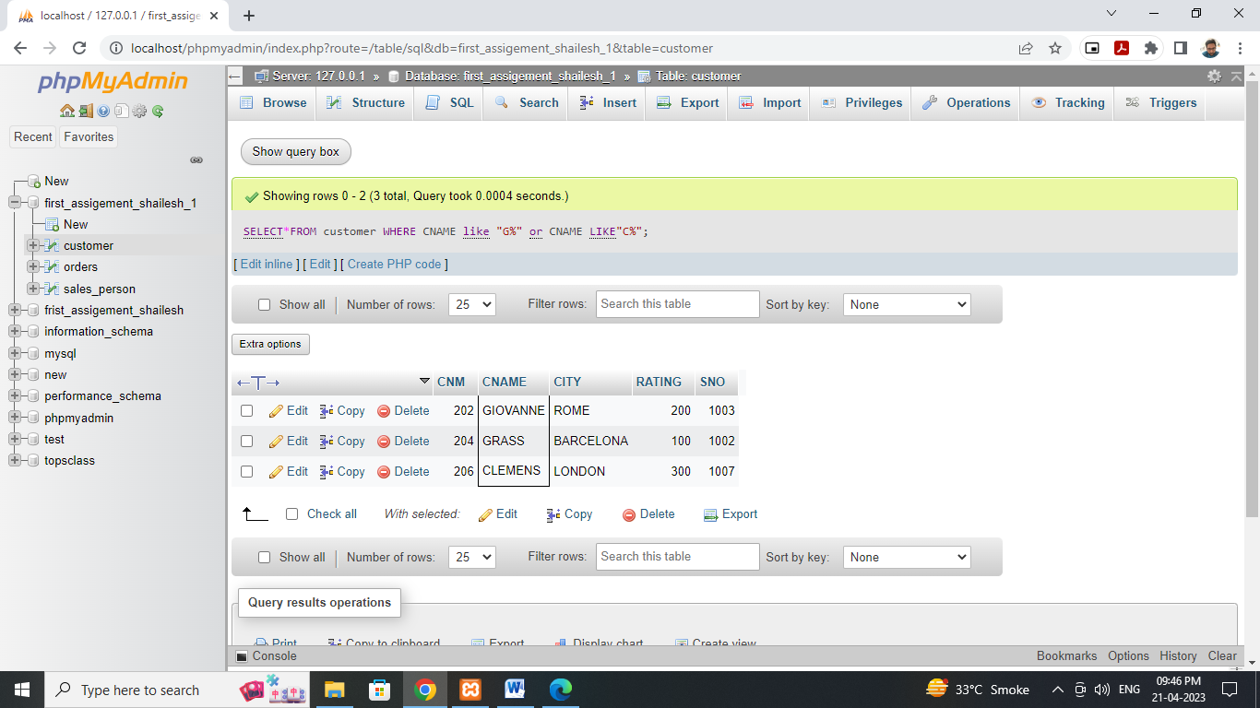

9) All customers excluding those with rating <= 100 unless they are located in Rome.

SELECT*FROM customer WHERE RATING<=100 and CITY="rome"

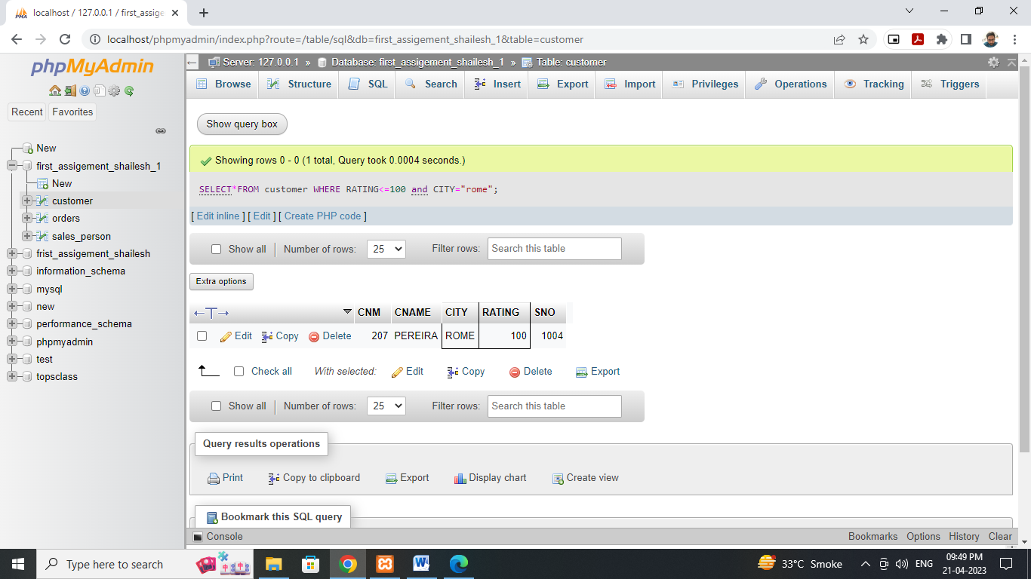

10) All orders except those with 0 or NULL value in amt field.

UPDATE orders set amt="0" WHERE ONM=3005

UPDATE orders set amt="" WHERE ONM=3010

SELECT*FROM orders WHERE amt="0" or amt="num";

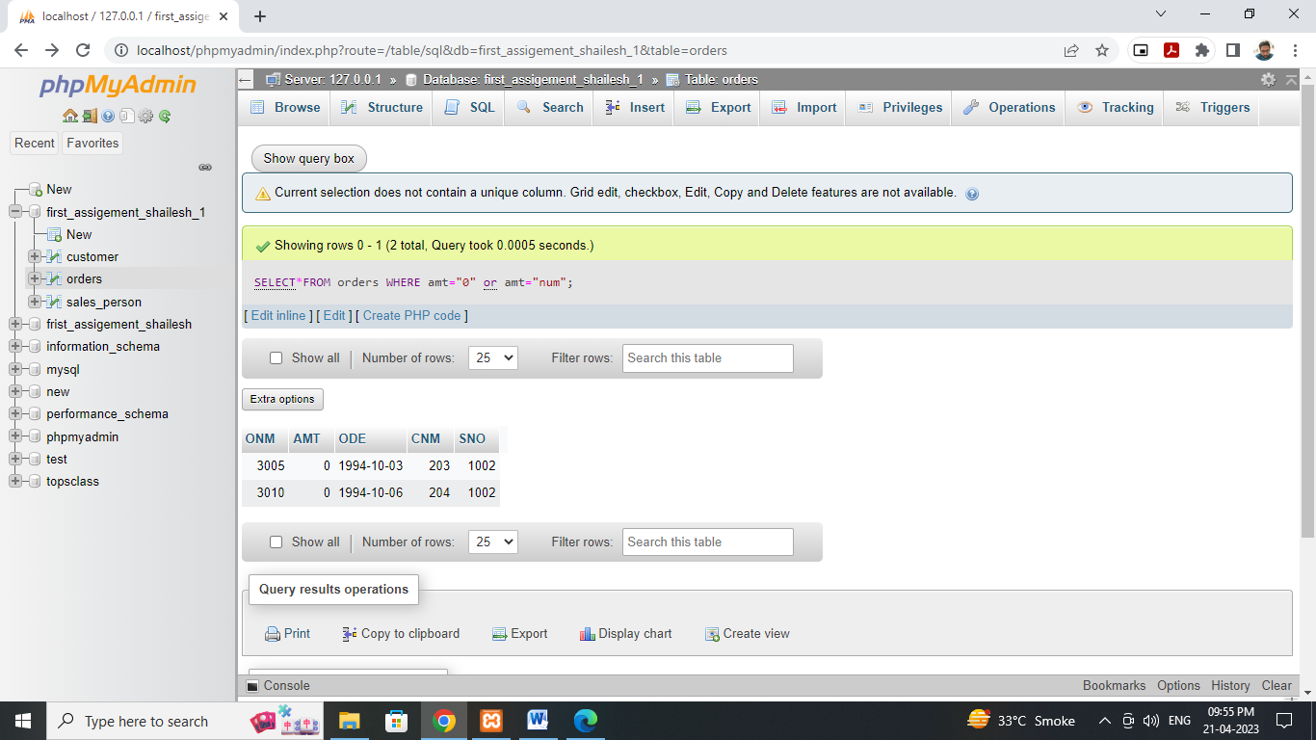

11) Count the number of salespeople currently listing orders in the order table.

SELECT COUNT(DISTINCT sno) FROM orders;

